**LAB PROGRAM 6(ORDER DATABASE) NAME:TARUN SRIRAM DAMMU**

**USN:1BM19CS171**

**QUERIES**

create database orderdb;

use orderdb;

create table salesman (

salesman_id int(4),

name varchar (20),

city varchar (20),

commission varchar (20),

primary key (salesman_id)

);

desc salesman;

create table customer1 (

customer_id int(4),

cust_name varchar (20),

city varchar (20),

grade int (3),

salesman_id int(4),

primary key (customer_id),

foreign key (salesman_id) references salesman(salesman_id) on delete set null

);

desc customer1;

create table orders (

ord_no int (5),

purchase_amt int (10),

ord_date date,

customer_id int(4),

salesman_id int(4),

primary key (ord_no),

foreign key (customer_id) references customer1 (customer_id) on delete cascade,

foreign key (salesman_id) references salesman (salesman_id) on delete cascade

);

desc orders;

insert into salesman values (1000, 'john','bangalore','25 %');

insert into salesman values (2000, 'ravi','bangalore','20 %');

insert into salesman values (3000, 'kumar','mysore','15 %');

insert into salesman values (4000, 'smith','delhi','30 %');

insert into salesman values (5000, 'harsha','hydrabad','15 %');

select * from salesman;

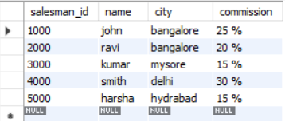

insert into customer1 values (10, 'preethi','bangalore', 100, 1000);

insert into customer1 values (11,'vivek','mangalore', 300, 1000);

insert into customer1 values (12, 'bhaskar','chennai', 400, 2000);

insert into customer1 values (13, 'chethan','bangalore', 200, 2000);

insert into customer1 values (14, 'mamatha','bangalore', 400, 3000);

select * from customer1;

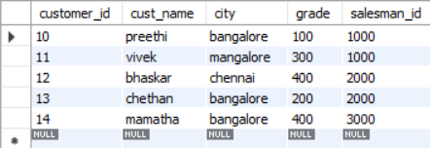

insert into orders values (50, 5000, '04-06-17', 10, 1000);

insert into orders values (51, 450, '20-01-17', 10, 2000);

insert into orders values (52, 1000, '24-02-17', 13, 2000);

insert into orders values (53, 3500, '13-04-17', 14, 3000);

insert into orders values (54, 550, '09-03-17', 12, 2000);

select * from orders;

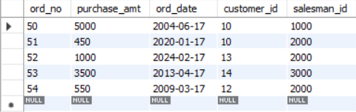

-- Query 1

select grade, count(distinct customer_id)

from customer1

group by grade

having grade > (select avg(grade)

from customer1

where city='bangalore'

);

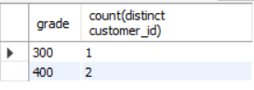

-- Query 2

select salesman_id, name

from salesman a

where 1 < (select count(*)

from customer1

where salesman_id=a.salesman_id

);

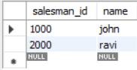

-- Query 3

select salesman.salesman_id, name, cust_name, commission

from salesman, customer1

where salesman.city = customer1.city

union

select salesman_id, name, 'no match', commission

from salesman

where not city = any

(select city

from customer1)

order by 2 desc;

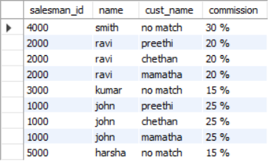

-- Query 4

create view highsalesman as

select b.ord_date, a.salesman_id, a.name

from salesman a, orders b

where a.salesman_id = b.salesman_id

and b.purchase_amt=(select max(purchase_amt)

from orders c

where c.ord_date = b.ord_date

);

select * from highsalesman;

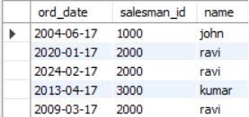

-- Query 5

delete from salesman

where salesman_id=1000;

select * from salesman;

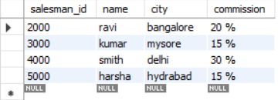

select * from orders;

